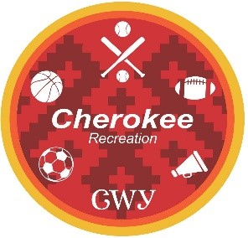
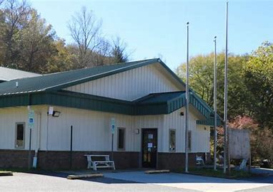

Kamiyo Lanning
NCSU PRT 508 Summer 2022

Risk Management Plan
Cherokee Recreation Youth Sports
Focus on Wrestling Program
Location: Wolftown Sports Complex

Table of Contents
Introduction…………………………………………………………………………………….2
Inherent Risks………………………………………………………………………..2
Safety Measures………………………………………………………………………………3
Personal Protection Apparel and Equipment………………………….3
Facility and Equipment Inspections…………………….………………….3
Special Risks…………………………………………………………………………………….3
Concussions………………………………………>………………………………….3
Wrestlers Ear………………………………………………………………………….3
Incident and Accident Reporting………………………………………………………4
Emergency Action Plan…………………………………………………………………….4
Travel Policy…………………………………………………………………………………….4
Staff Driving Verification
Traveling to Tournaments
Instruction and Supervision……………………………………………………………..5
Instruction Guidelines
Oversight
Employment Process and Training……………………………………………………5
Employees and Coaches
Volunteers
Participant Agreement and Code of Conduct…………………………………..7
Appendix………………………………………………………………………………………11

Introduction
Qualla Clans Wrestling Club is a programmed sport activity overseen by the Cherokee Recreation department for the Eastern Band of Cherokee Indians. The participants range in ages from five years old to seventeen years old. Participation numbers for the past two years have ranges from 14-26 participants any given time with 3 committed volunteer coaches and high school students that volunteer their time, but not on a specific schedule.

Practices are held Monday, Tuesday, and Thursday evenings from 5:00pm to 7:00pm from October through May at the Wolftown Sports Complex located at 27 Long Branch Road, Cherokee, NC 28719.

Inherent Risks
As in any sport that are risks that participants, coaches, and parents should be aware of. Our club’s position is to make sure that safety equipment (headgear) is provided for each participant. Coaches are trained and certified with USA Wrestling Coaching certifications. These precautions should help reduce:
- Heat exhaustion
- Muscle pulls/tears
- Eating Disorders
- Wrestlers Ear
- Loss or damage to personal property
- Injury from uninspected equipment, materials, or property

Risk Management philosophy is to be proactive in preventing injuries by providing safety equipment, safe learning environment, and certified coaches. Participants will be educated on code of conduct, signed liability waivers, and safety procedures.

Safety Measures
Personal Protection Apparel and Equipment
Each participant is provided with wrestling helmet, singlets, and wrestling shoes. Mats are cleaned before and after practices with wrestling mat specific cleaning products. Shoes are only to be worn on wrestling mats, not outside to prevent debris from being spread from outside to the tops of wrestling mats.

Facility and Equipment Inspections
Wrestling mats are inspected by Recreation staff daily and before usage of the wrestling club. The head wrestling coach also inspects before each practice to make sure that the mats are connected, and seams are not showing, to prevent injury. Wrestling helmets are adjusted and fit to each wrestler, they are assigned to the participant but double checked before practice begins. Helmets are required to be worn in Qualla Clans practices to prevent Wrestlers Ear. Checklist is initialed by the coach or appointee and the Recreation Staff that is on duty at the facility.

Special Risks
Concussions
Concussion is a result of head trauma. These are reduced with education on correct wrestling techniques, but all coaches, participants, and staff are educated through National Alliance for Youth Sports concussion training.

Wrestlers Ear
Wrestlers Ear is a result of multiple hits to the ear where blood is drawn to the surface. Although this is cosmetic and no real harm can come from it, it is something that can be prevented with a wrestling helmet. In many organizations practices are helmet optional but in Qualla Clans it is mandatory.

Incident/Accident Reporting
The Cherokee Recreation Department follows Risk Management Plan in place for the Eastern Band of Cherokee Indians. If an injury and/or accident occurs and a participant, coach, or staff member is injured the Facility supervisor needs to be notified immediately following emergency services if necessary. Once they are notified the employee on duty or supervisor is responsible for making sure that Incident Report forms are filled out for the participant, employee who was on duty, and witness form for coaches (See Appendix A, B, C). This are turned in immediately to the Manager of Cherokee Recreation and Risk Management department who will open a case and follow through with conclusions of all injuries and verify if further steps need to be taken.

Emergency Action Plan
See attached

Travel Policy
Staff Driving Verification
All staff are cleared for driving tribally owned vehicles (See Appendix D).

Traveling to Tournaments
Practices are held in one location and parents/guardians drop off and pick up participants so no traveling for practices is required from Cherokee Recreation. Traveling to Tournaments outside of a 100-mile radius is provided by Cherokee Recreation and it is mandatory that participants ride to and from the tournament in tribal vehicles, which are driven by Cherokee Recreation staff. Parents are welcome to attend tournaments but are not allowed on the vehicles for travel. If a participant must ride with a parent in either direction, the parent will be responsible for transportation to and from the tournament.

Instruction and Supervision
Instruction Guidelines
  - No Participant can start without going through concussion training.
  - Participant will be fitted with helmet before practice, if returning participant, the helmet will be checked before practice for accurate fit.
  - Each participant will be dress out in proper attire and wrestling shoes, to protect the wrestling mats.
  - Participants are matched up based on weight class and skill level. Certified coaches will determine best match ups.
  - No Participant is left alone with any adult, coach or not, at any time. Two adults are always required. Maximum capacity is 24 participants for the two wrestling mats at the facility. Larger numbers are ok but must ensure that another adult is available to help monitor.
Oversight of program
  - The facility Supervisor along with the department Manager will be responsible for maintaining records for the coaches’ certifications.
  - It is the responsibility of the Cherokee Recreation program to make sure they are up to date.
  - There must always be two adults with participants. No adult should be left alone with a participant at any time.
  - Volunteers are accepted if training is completed.

Employment Process & Training
All Tribal Employees go through strict federal background checks and driving clearance checks before they are employed. If the coach is already a tribal employee, they are cleared of the background check, but will have to clear the remaining trainings. Coaches are accepted based on their history with Wrestling as participants or coaches. Reference checks and experience are expected.

At the end of each season coaches will be reviewed by their peers and participants. This will help the Department maintain high standards of coaching.

Employees and Coaches
  - Must be 18 years of age.
  - Do not have to be an employee of Cherokee Recreation.
  - Must complete and maintain USA Wrestling Coaches Certification
  - Must complete and maintain CPR and First Aide Certification.
  - Must complete and maintain Concussion Training.
  - Complete Federal Background Check must be completed, with no charges or history of child abuse, sexual abuse, or misconduct that prevents clearance of working with children according to the Cherokee Codes of Conduct.
Volunteers (not Coaches)
  - If 16-17 years of age, must be supervised as though they are a participant.
  - 18 years of age or older, must pass a background check and concussion training, but like coaches may not be left alone with a participant.

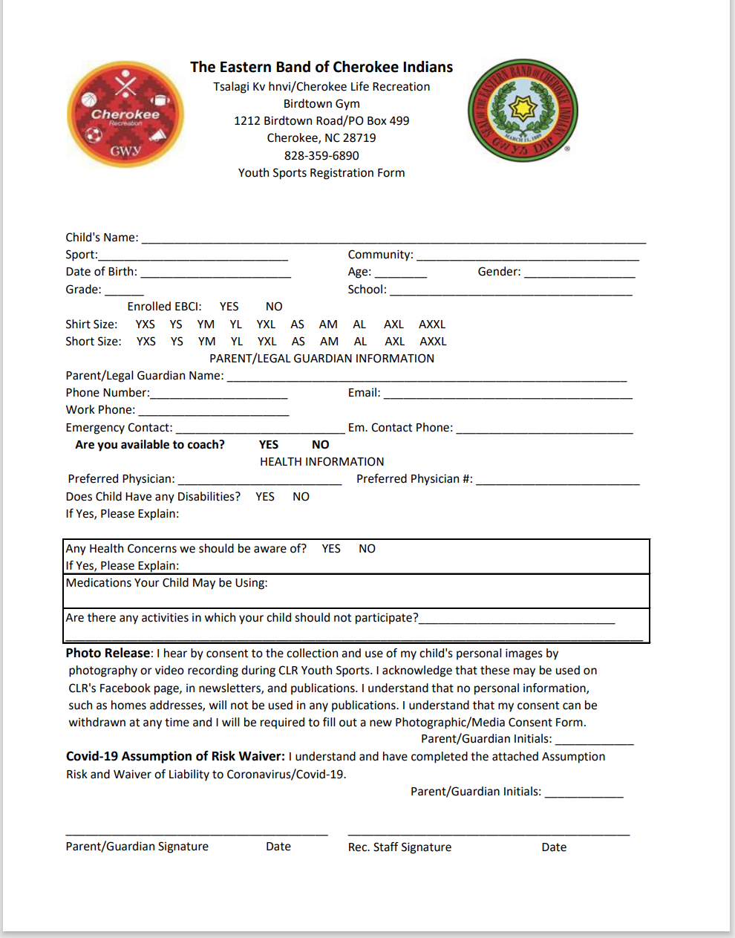
Participant Registration and Code of Conduct

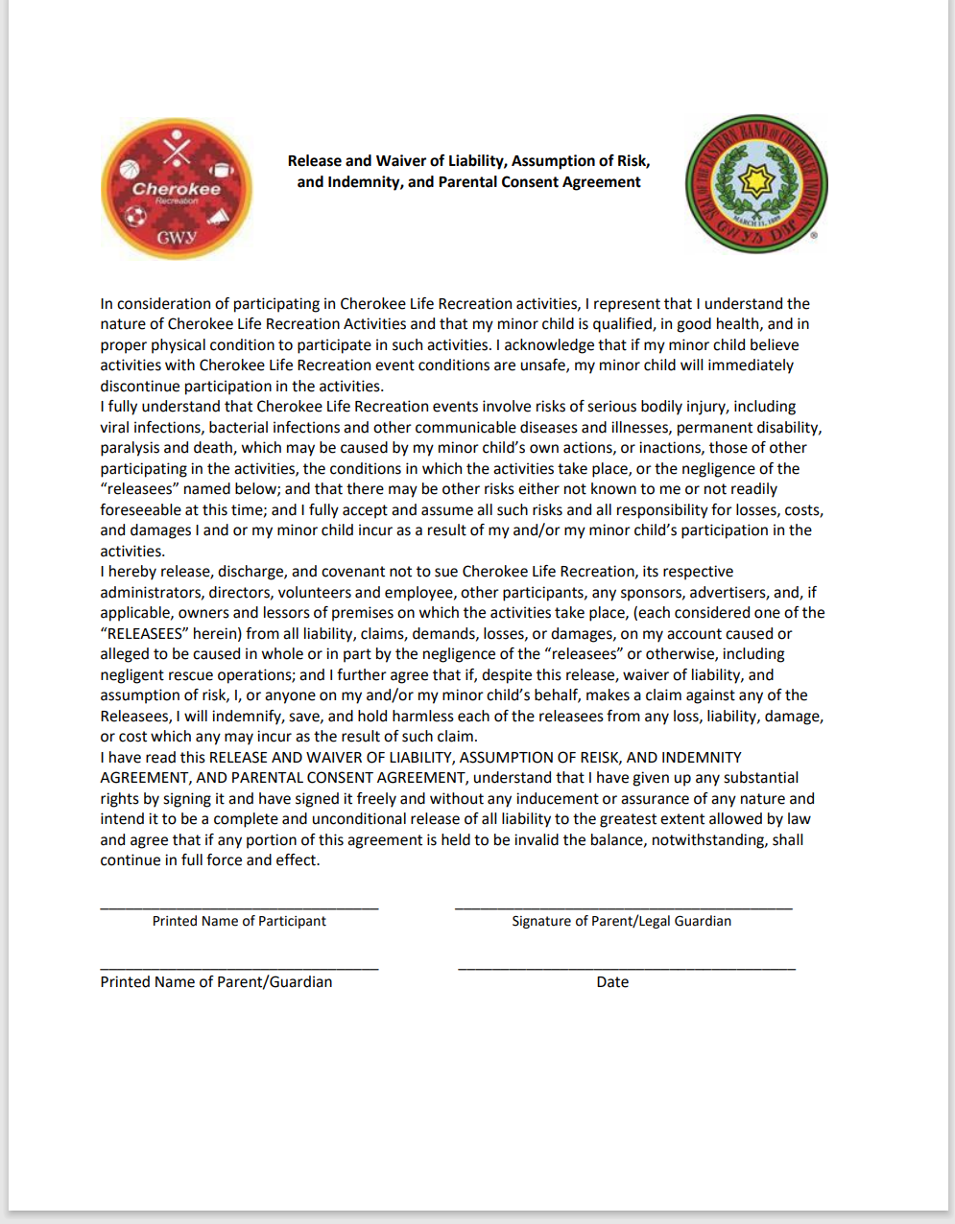

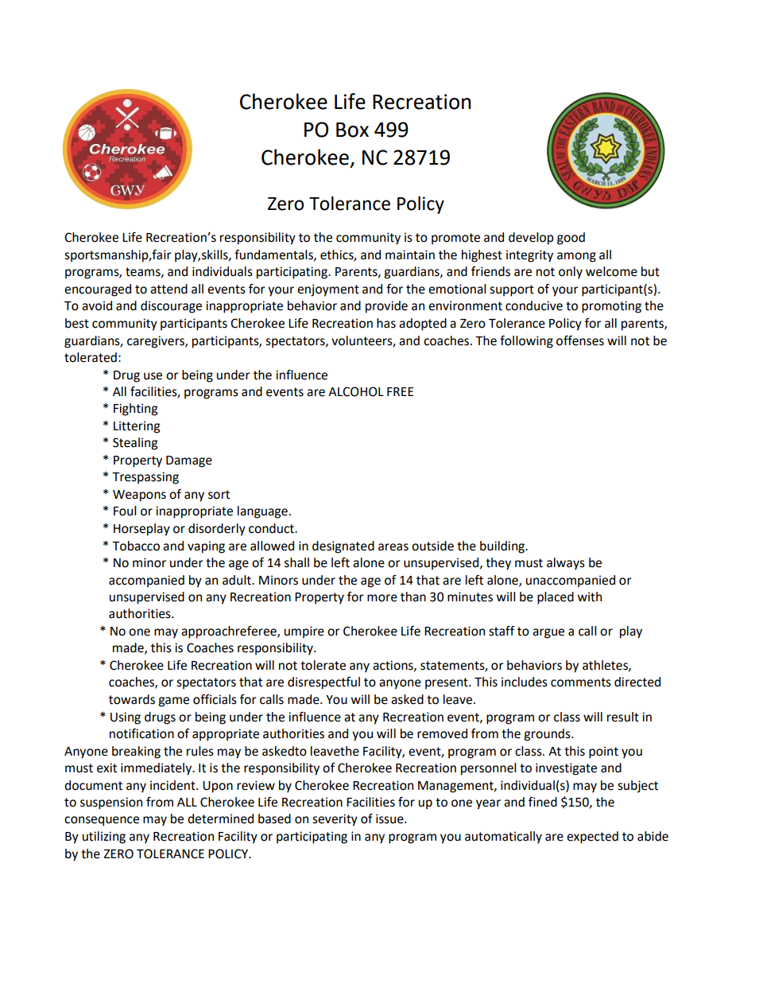
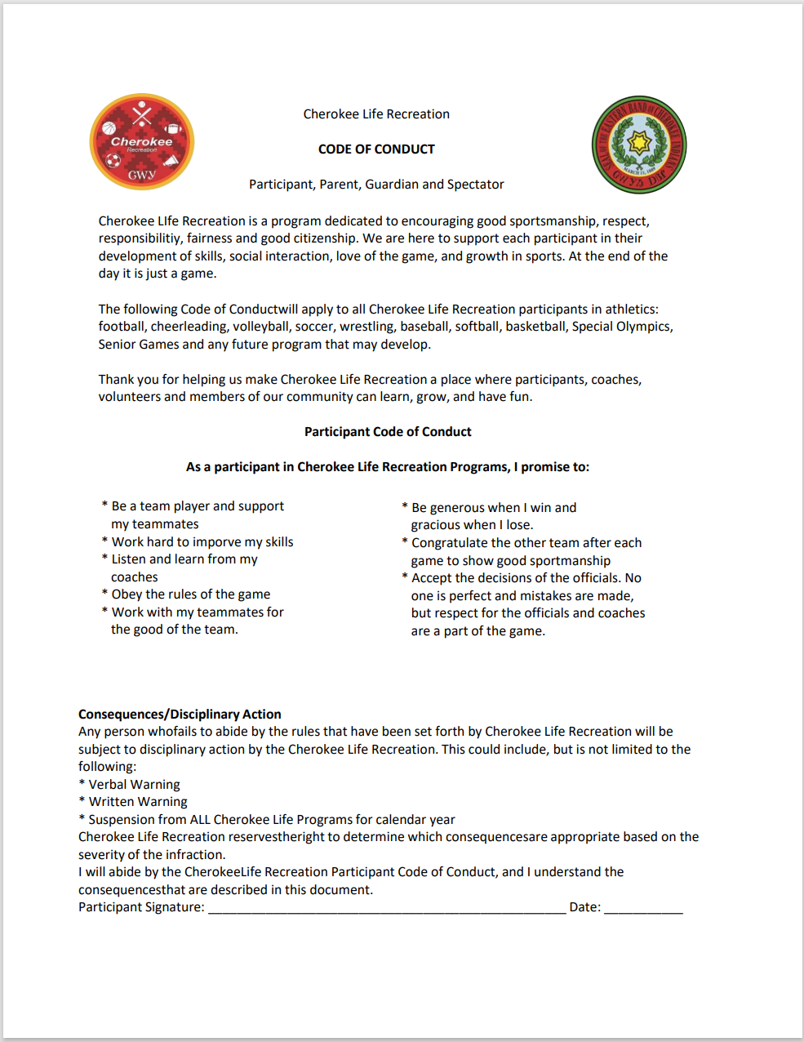

Appendix A

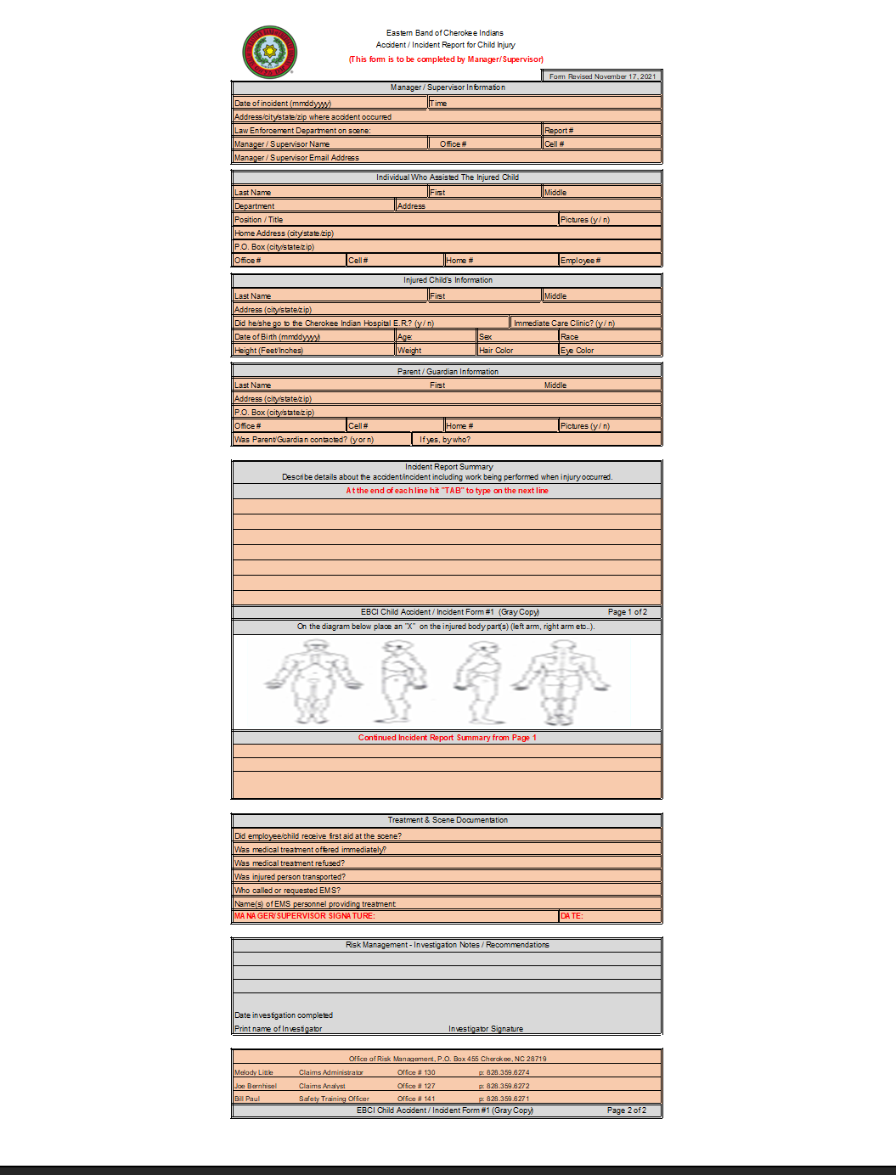

Appendix B

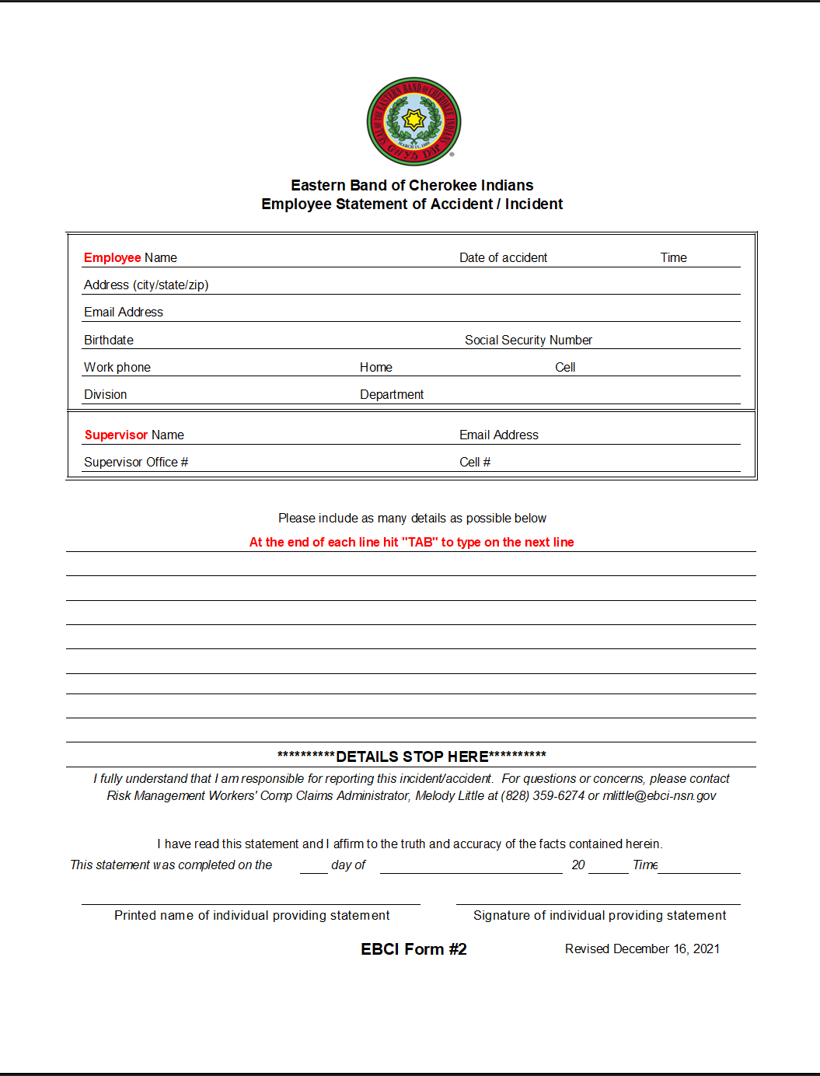

Appendix C

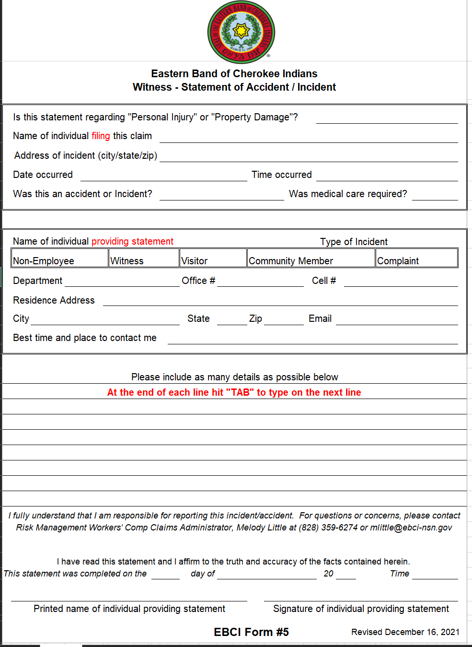

Appendix D

